

Current Available Spaces

**Warehouse Space:**

* **145DE New Street**- 1,000 sq ft, open warehouse space with drive-in dock, concrete floors, high ceilings. **$1,000 /rent/mo/NNN** + $100.00 CAM (No Utilities included)

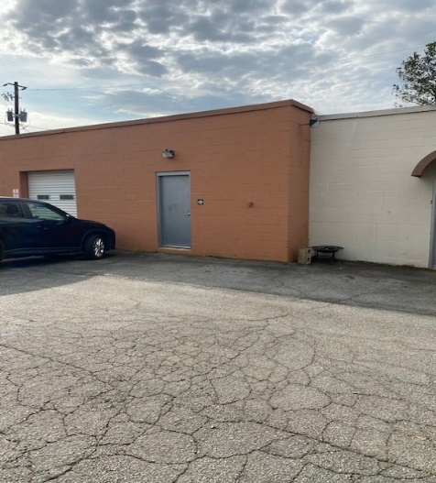 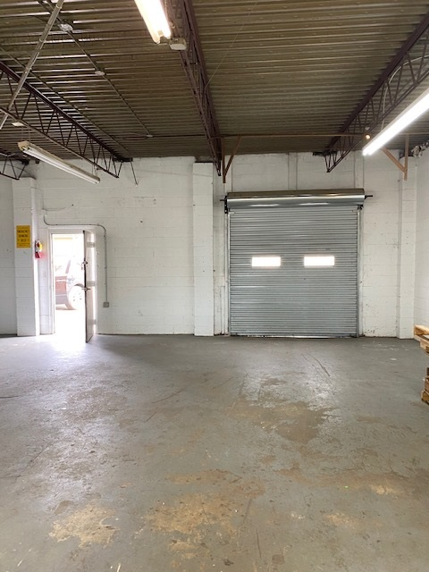

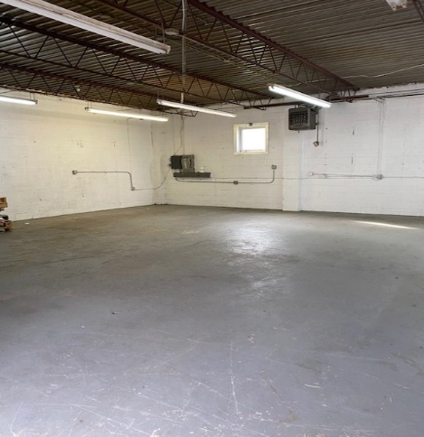

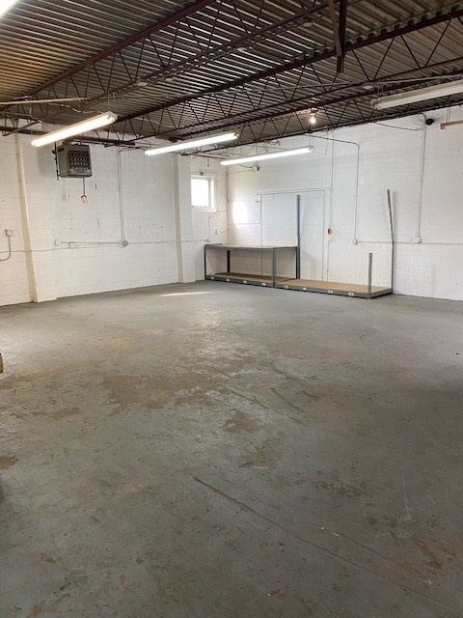

**Leasing requirements-**

* **Personal guarantee required**
* **Personal credit score of 675 or more required**
* **First month’s rent and security deposit due at lease signing**
* **RENT + CAM + UTIL+ TI + HVAC replacement fee= monthly payment**
* **$55 application fee**

**Broker Commission:**

* ***Brokers to be paid ½ of first month’s rent with 5% residual.***
* **Brokers must make first contact with EDS Leasing office for commission to paid on executed leases by EDS. If EDS shows the tenant the property first, tenant will be responsible for Broker’s commission.**